**How to Upload an Input File to Aleph**

Created by Jaime Taylor, 5/5/15

In order to perform services on a set of records with non-sequential system numbers, you will need to create a list of those numbers as a text file, and then upload that list to Aleph, to be used as an input file. You can then retrieve that set of records (via ret-01 or ret-03), and perform other batch services.

1. Create a list of Aleph system numbers, as instructed in “Create an Input File for Aleph.”

2. Open FileZilla & connect to Aleph Production (67.111.179.150), and then to: /exlibris/aleph/u22_1/alephe/scratch

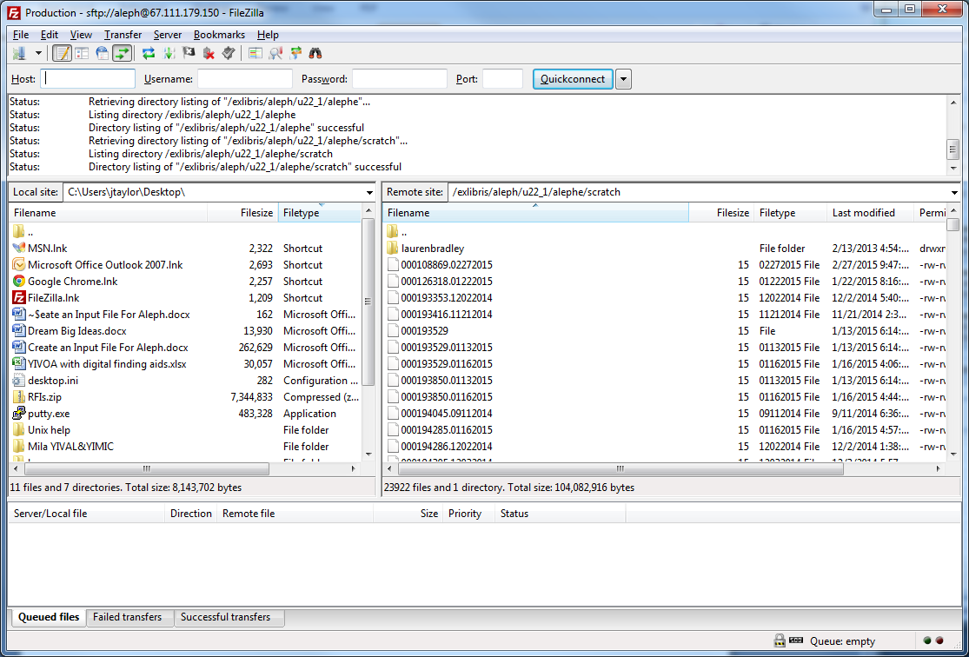

3. Transfer the file containing the system numbers to Aleph scratch – double click on the file to transfer, it will move to the other side. You can see the queued, failed, or successful transfers in the tabs at the bottom left corner of the window.



4. The file is now available in Aleph as an input for batch services, by entering the exact file name in the “Input File” field.

