**How to Make a Spreadsheet with MarcEdit**

July 3, 2017 | J. Taylor

1. Retrieve & export records from Aleph. (See document "How to Export MARC Records from Aleph.”)
2. In MarcEdit, go to Tools>Export>Export Tab Delimited Records. 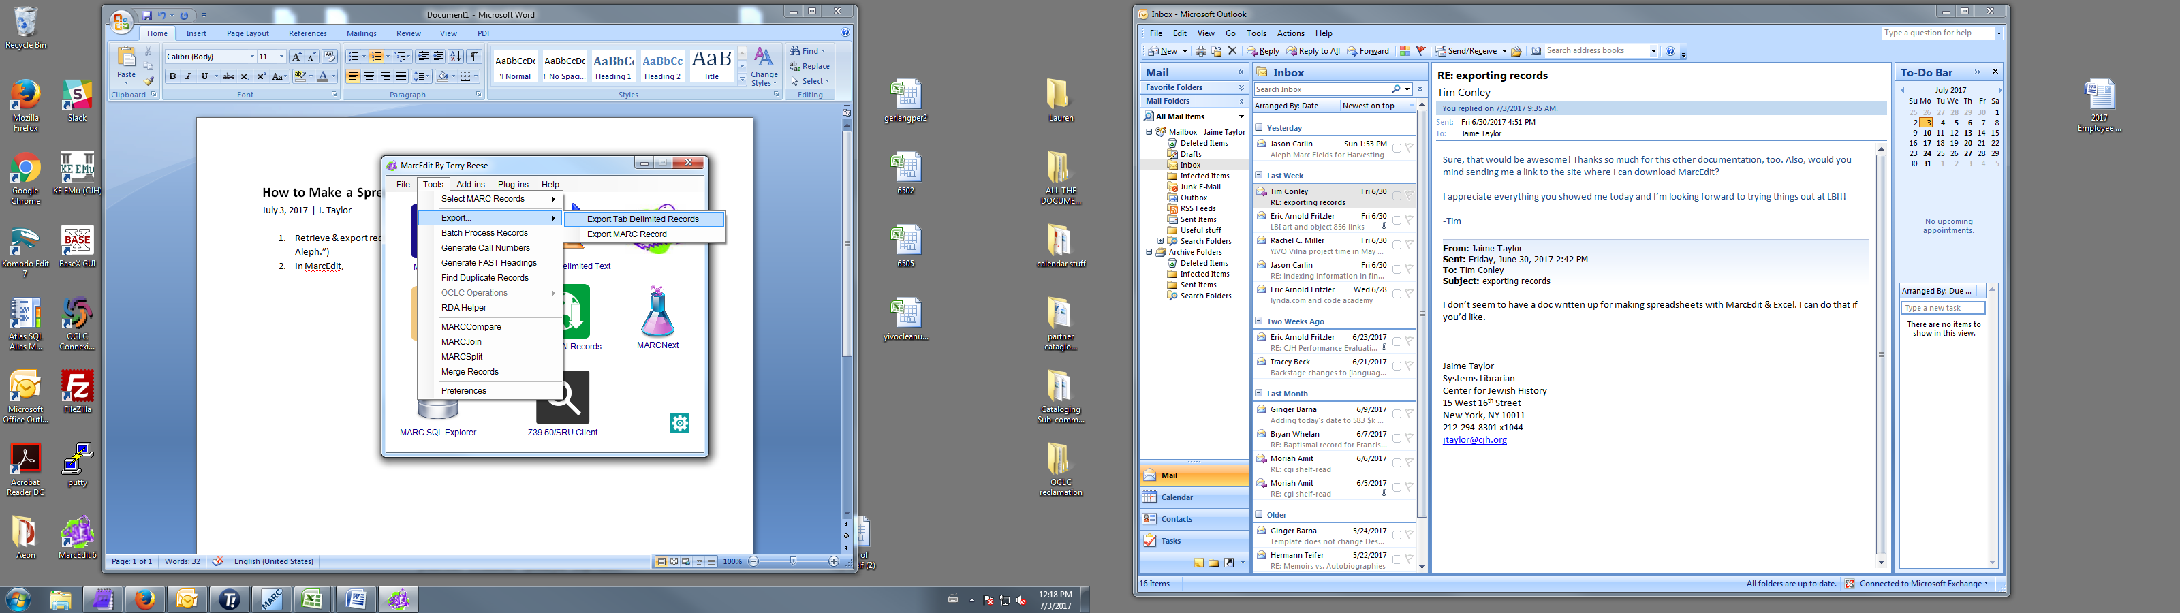
3. Click on the little folder icons to choose the file to export records from and to name the new file. Change the field delimiter if you want to (but you probably don’t want to), then click Next. 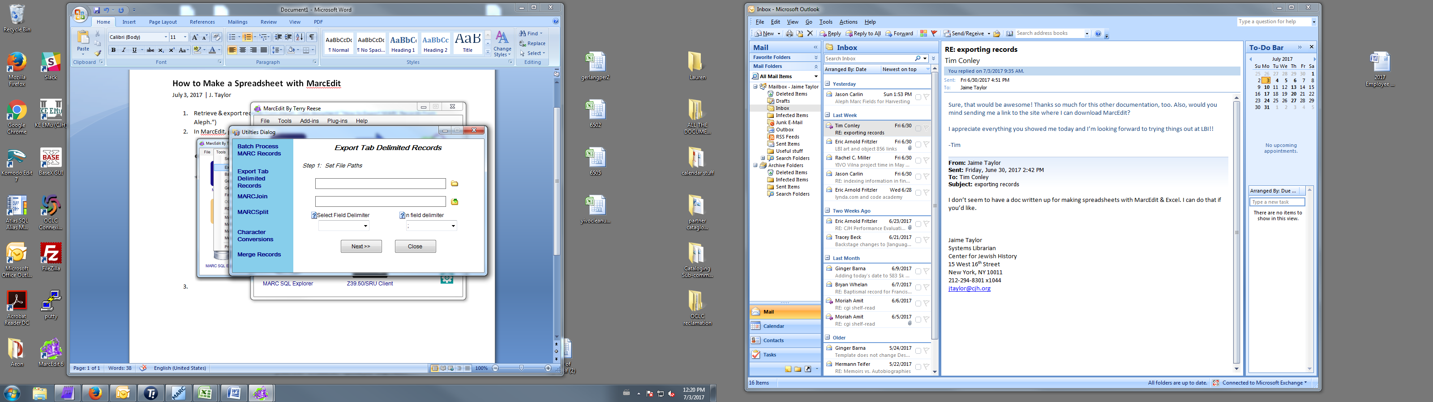
4. Use the Field and Subfield boxes to create a list of fields that you want in your spreadsheet. This can include proprietary Aleph MARC fields, as long as you exported them from Aleph correctly. If you want all the subfields in a field, don’t type anything to the Subfield box. Click Export. The file will appear on your desktop, or wherever else you saved it.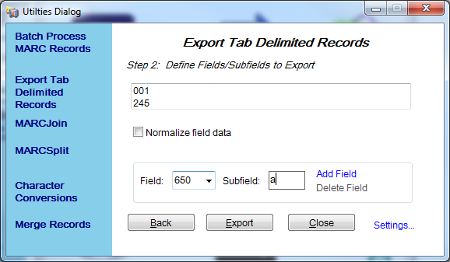
5. Open Excel. Click on the Data tab and select From Text. 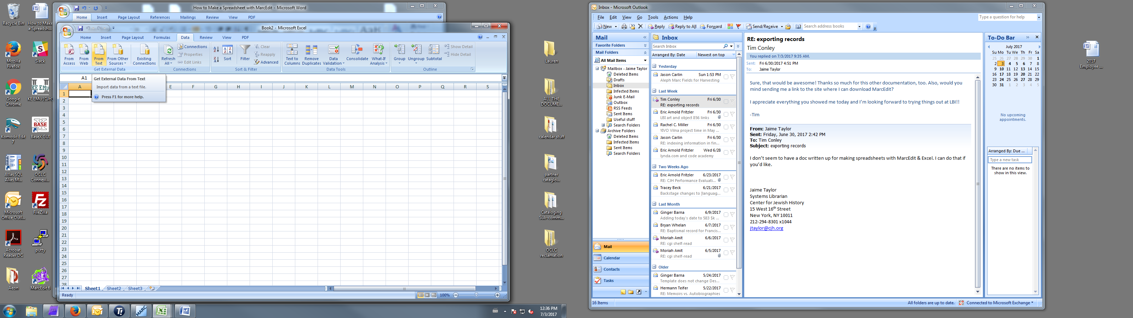
6. In the dialog box that pops up, select the file you want to import.
7. In Step 1 of the Text Import Wizard, choose “Delimited” or “Fixed Width,” then click next. Usually you will choose “Delimited.” 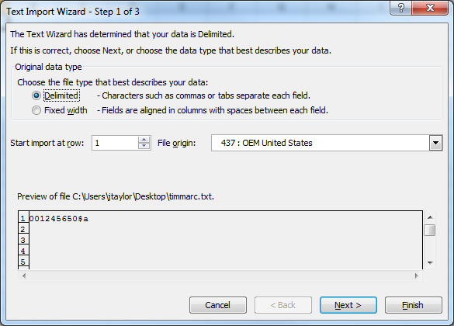
8. In Step 2, choose the delimiter character (usually Tab), ***or***, if you chose “fixed Width” above, the width of the fields. 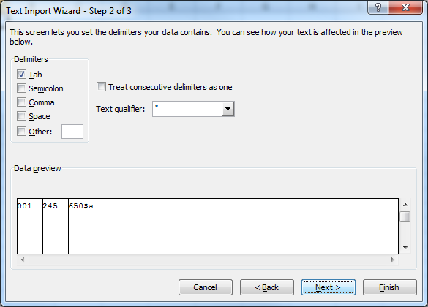

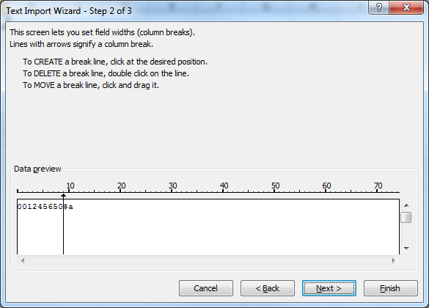

1. In Step 3, change the format of each column to Text by clicking in the column in under “Data preview” and then changing the radio button. Click Finish.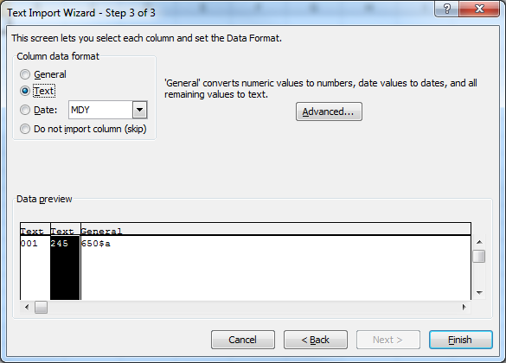
2. Click OK on the Import Data dialog pop-up box. The data from the MARC records will populate a spreadsheet, with each records fields in a row, and each instance of a field in a column.

