Updated by Jaime Taylor 3/25/2015

**How to Delete a Record from Aleph**

There are a couple ways to delete records from ALEPH, however this is the safest way to do it. **Once data is deleted, it’s gone!** Do not delete records unless you are absolutely sure.

Before we get started, it’s helpful to understand the structure of a record. It has four parts: a bibliographic record, an administrative record, a holding record, and item(s) record(s). Every record in ALEPH needs at least a bib record and an ADM record. In order to have an item record, you must have a holding record. The ADM record is automatically generated whenever you create a new bib record. It has little data but its job is to hold all the other records to one another. See diagram below.

If your organization keeps accession records, these will need to be moved to another bib record, or else they too will be deleted. If your organization does not keep accession records, do not worry about this step. If your organization does keep accession records, consult your head librarian on what to do with accession records for deleted records, or contact the Systems Department.

To delete a record:

1. First open the items tab for the record that is to be deleted. Delete all items first by clicking on the Delete button on the right hand side of the Items List pane. When prompted with the “Are you sure you want to delete?” box, click Yes.

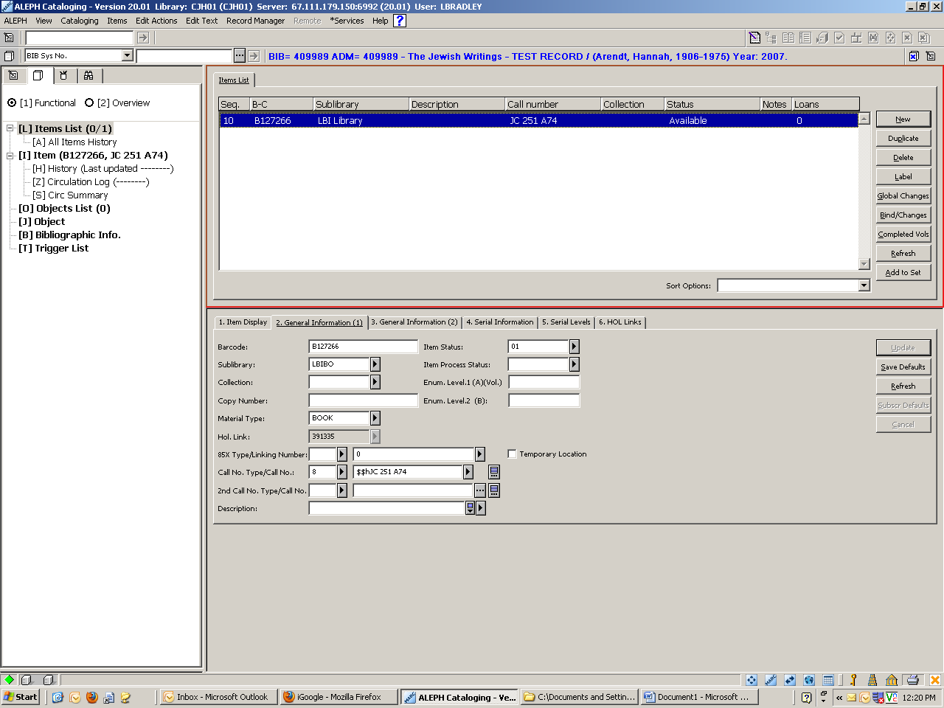

1. Next, open the HOL record in CJH60 (change under ALEPH dropdown at upper left) & edit bib record (icon at upper right). In top menu bar, go to Edit Text > Delete Record from Server [Ctrl +R]. Click Yes on the confirmation box.

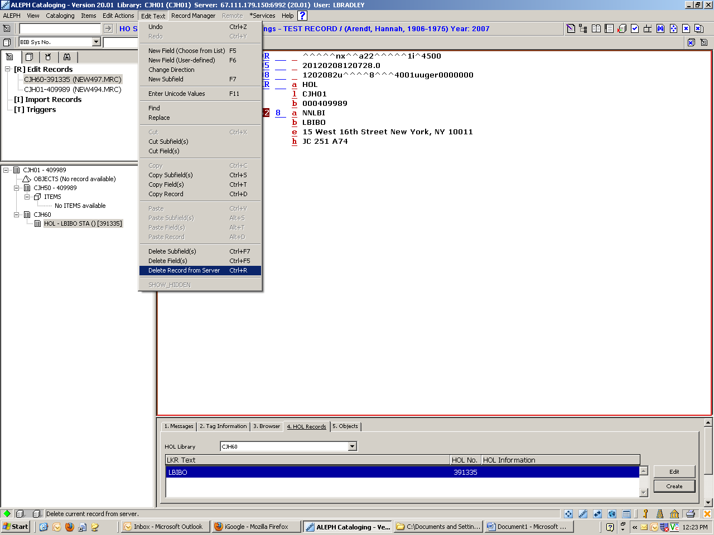

1. Open the ADM record. You can do this by clicking on the CJH50 record on the record tree. Repeat the action from Step 2 of going to Edit Text> Delete Record from Server [CTRL+R], Confirm.

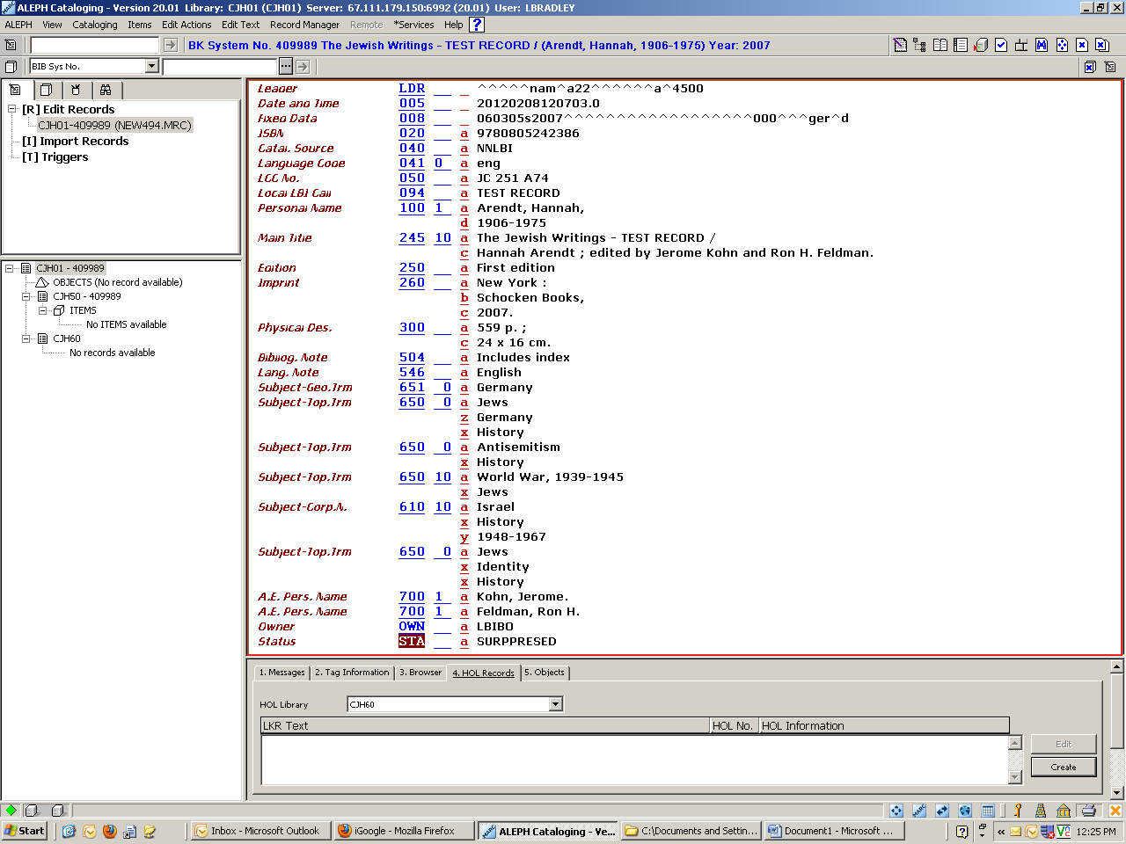

1. Lastly, you should be left with nothing but the bib record. If you look at the record tree on the left hand part of the screen, there should be no records attached. Repeat the action from Step 2 of going to Edit Text> Delete Record from Server [CTRL+R], Confirm.

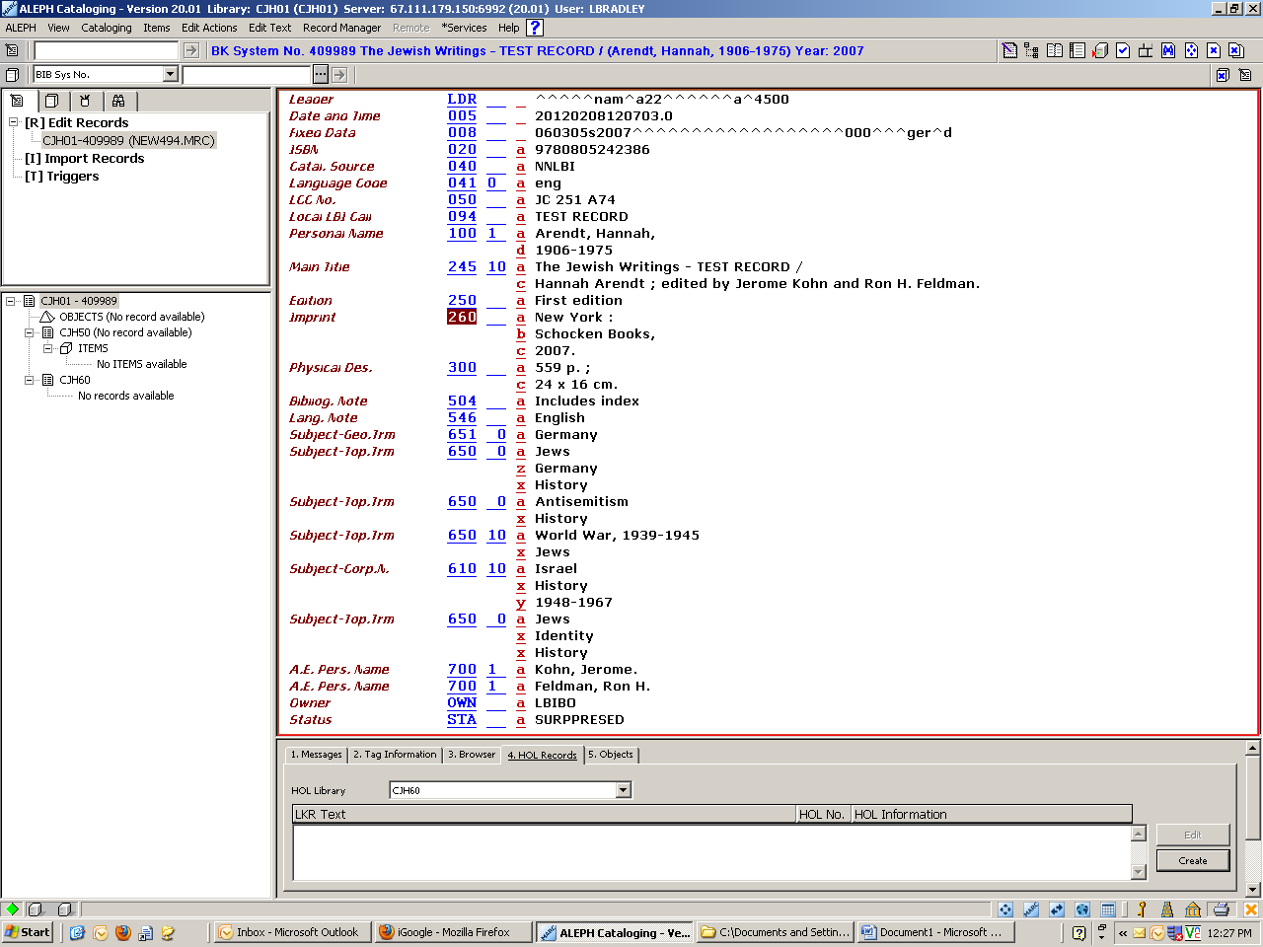

1. Your record has now been deleted off the server which means the data from it is not recoverable! Do not delete records unless you are certain that they should be deleted!