**Global Changes (Manage-21)**

1. Create a file with all the System Numbers to be changed. Put on server in 2 places: alephe/scratch and CJH01/scratch
2. Go to Services > Catalog Maintenance Procedures > Global Changes (manage-21)

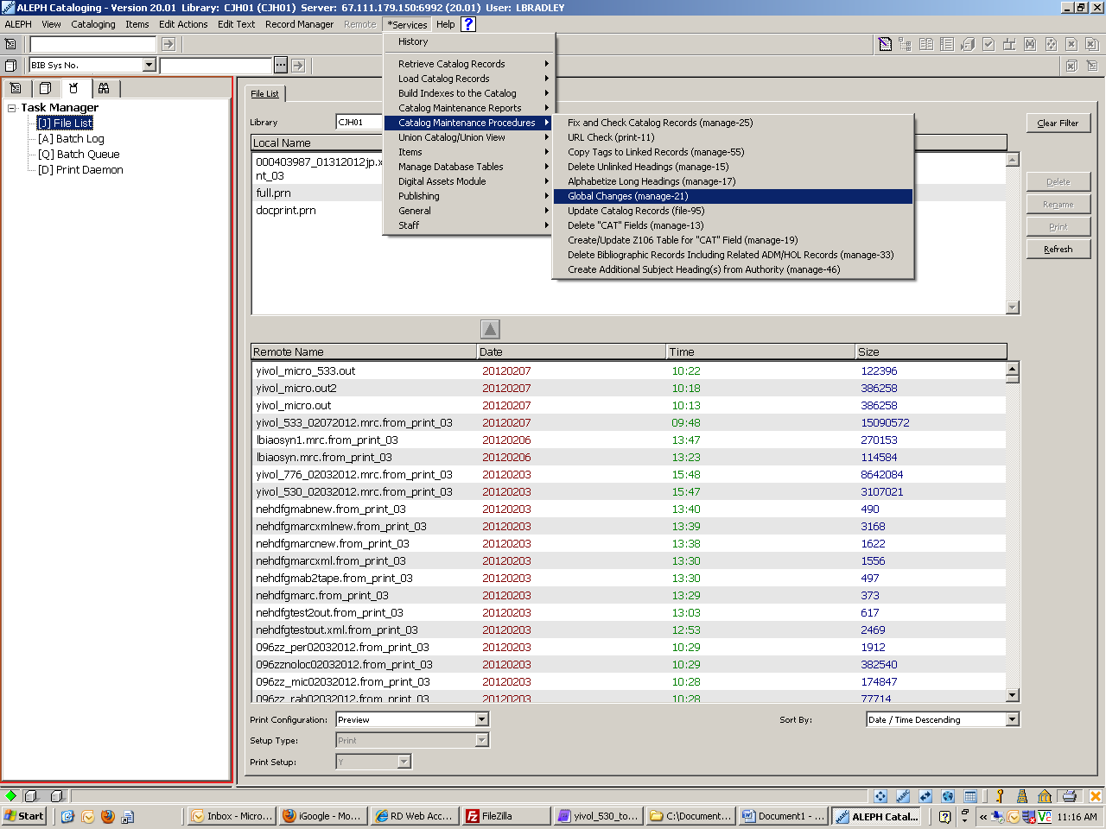

1. Input File should be the same exact file name as the file on the server. Use the ext. out for the output file. Enter in the tag for the field to be change, use # for all indicators, and whatever subfields need to be changed. Hit Submit.

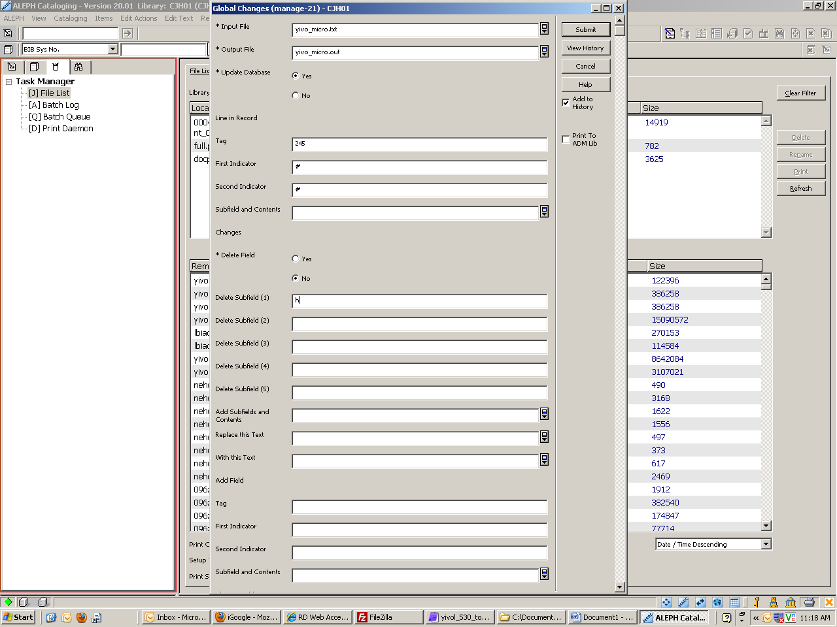

1. The .out file will appear in the task manager. You can move it to your local drive and view the changes from there.

