How to Export MARC Records from Aleph

1. If necessary, create an input file. If you are starting with a list of barcodes, you can use the list. If you are starting with system numbers, see the document “Create an Input File for Aleph.”
2. If necessary, ppload the input file to Aleph; see the doc “How to Upload an Input File to Aleph.”
3. Run a retrieval job to get the records. If retrieving by system number, use Retrieve Catalog Records (ret-01). If retrieving by barcode, use Retrieve Records by Direct Index (ret-06). In either case, the input file is the file you uploaded above. If using (ret-06), the Search Index is “BAR.”

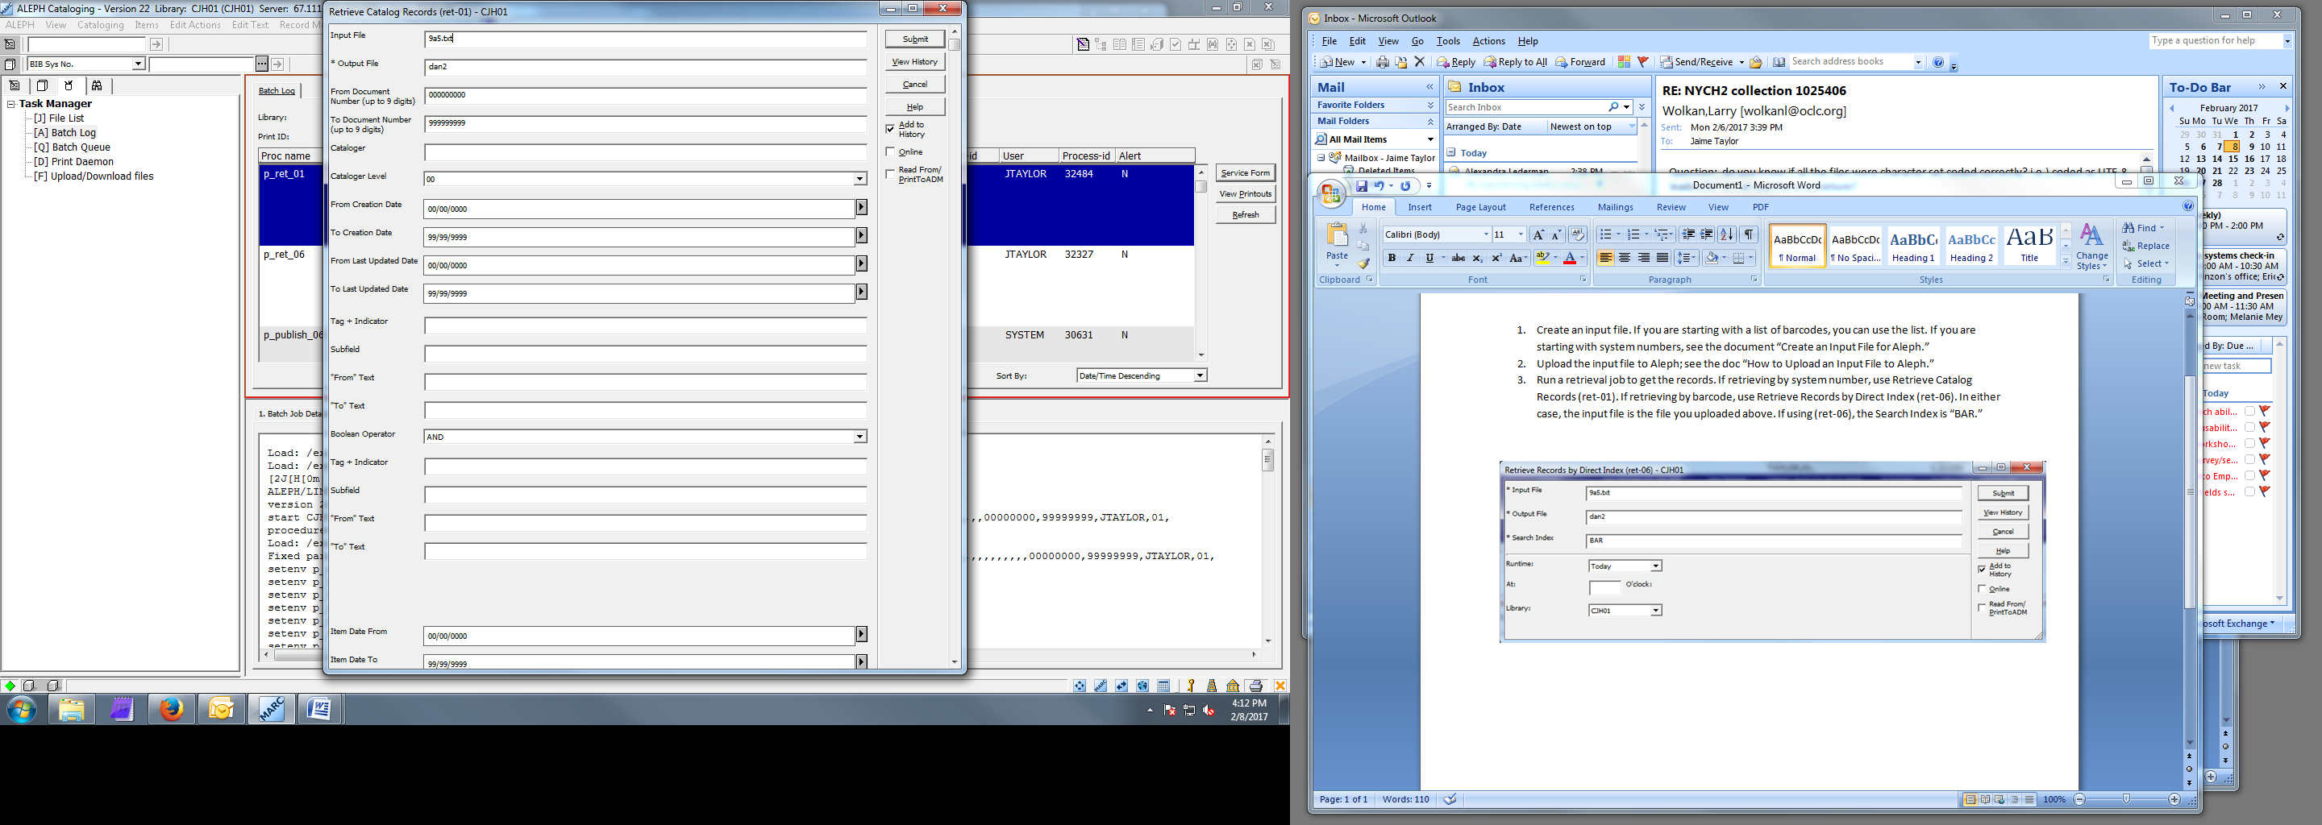

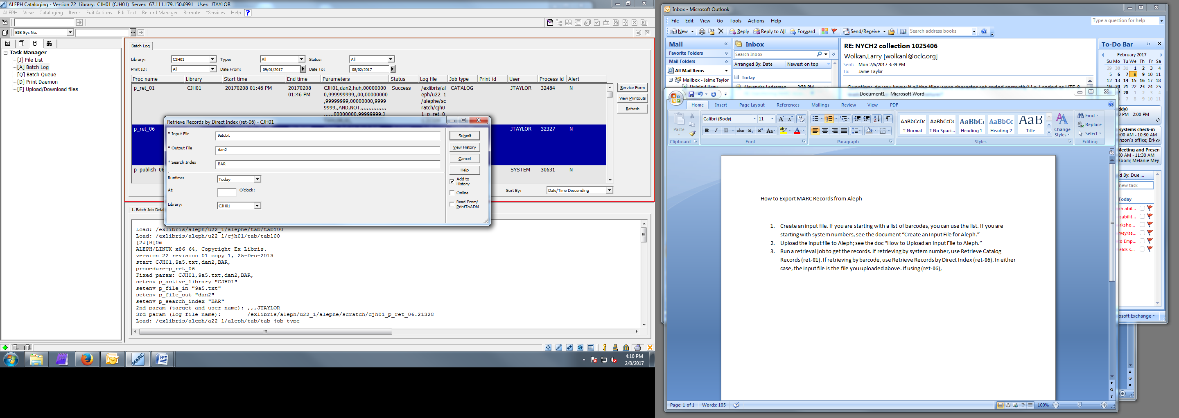

1. To export the retrieved records, run Download Machine-Readable Records (print-03). As the input file, use the output file from either (ret-01) or (ret-06). In Field 1, enter “ALL”; this will export all the fields in the records. If you wanted only select fields, you could enter the MARC fields & indicators on the lines for Field 1 through Field 8. In Format, choose “MARC with alphanumeric tags.” In Fix Routine, choose JPEX.

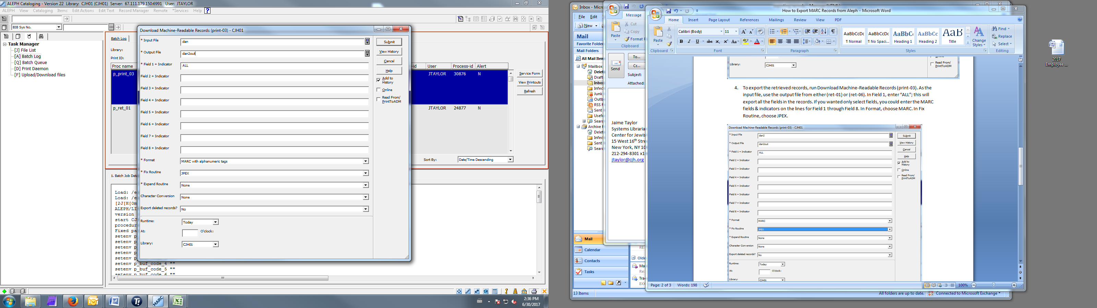

1. Transfer the resulting file to your local computer.