Downloading records from Aleph

Open the Aleph graphical client and log in to your Aleph account.

From the Services menu, select Retrieve Catalog Records -> Retrieve Catalog Records (ret-01)

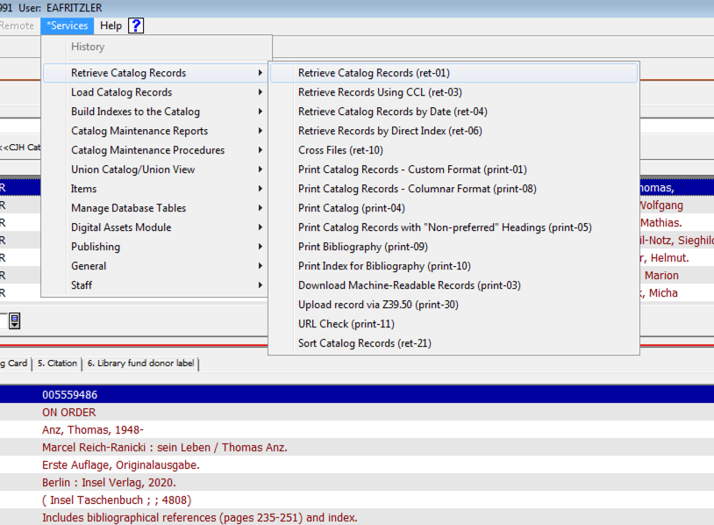

The service form opens. Here it is filled out with the same search we discussed in the tutorial, that is, a search for all records having a 655 field with the value “Electronic books.” The two hash marks after the 655 means “match any indicator.”

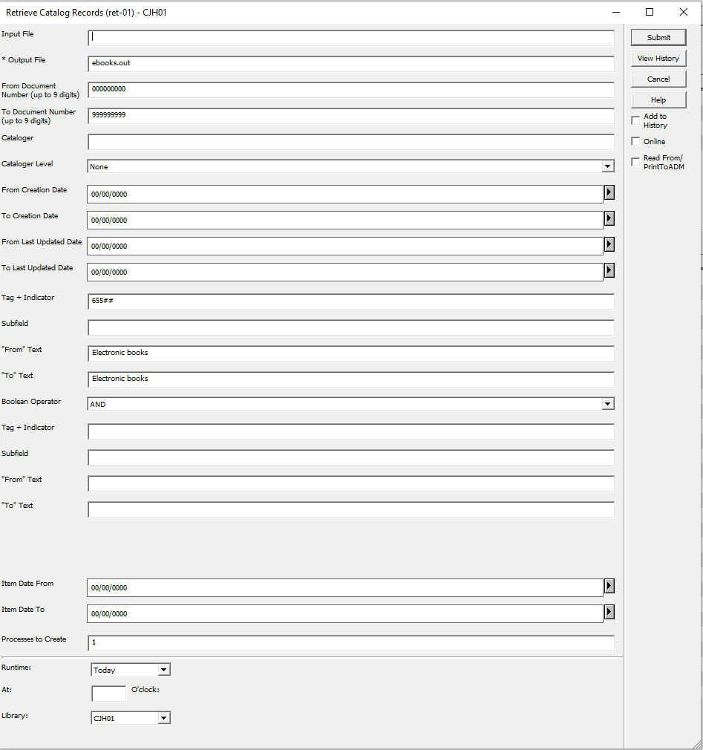

To reiterate a couple points from the tutorial:
• Always check “Add to History.” Should the search not return the results you anticipate, it’s useful to be able to use the “View History” button in the form and reload your search so you can tweak the parameters:
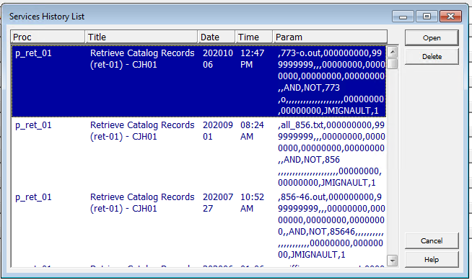

• Help is your friend. Though the service forms mostly act consistently, sometimes they don’t, and many times I have found the answers to my problems in the form help. This is especially true with regards to where Aleph expects to find its input and output files (it’s not always the alephe/scratch directory.)

When you are ready to run the search, click the “Submit” button. You can now follow the progress of your search in the “Batch log” tab of the Administration tab (the one that looks like a box with sticks in it; I have no idea what that is actually supposed to represent.)

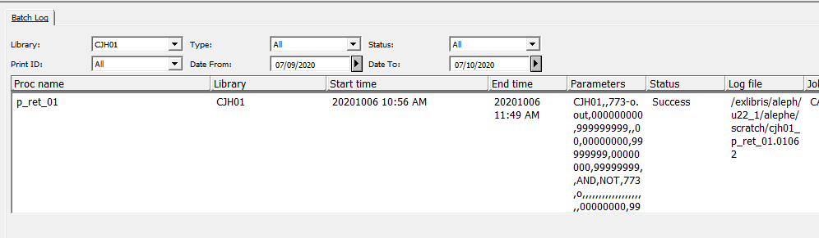

If the job runs with a “Success” result, you now have an input file with the system numbers of the records present in the alephe/scratch directory. Oddly enough, the “Upload/Download files” tab of the Administration tab won’t let you browse that directory, but you don’t really need to; you just need the file to be there for the next step in the process, which is to download the records.

So now, go to the Services menu again and select Retrieve Catalog Records -> Download Machine-Readable Records (print-03):

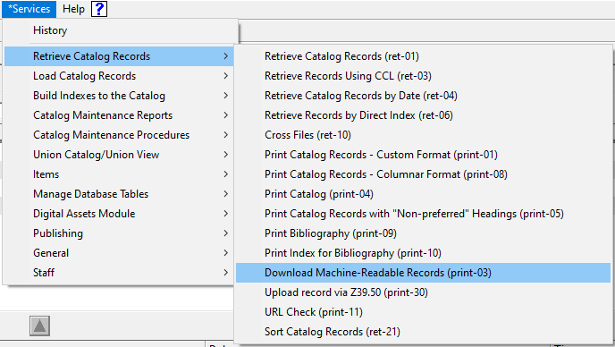

Again, the service form opens:
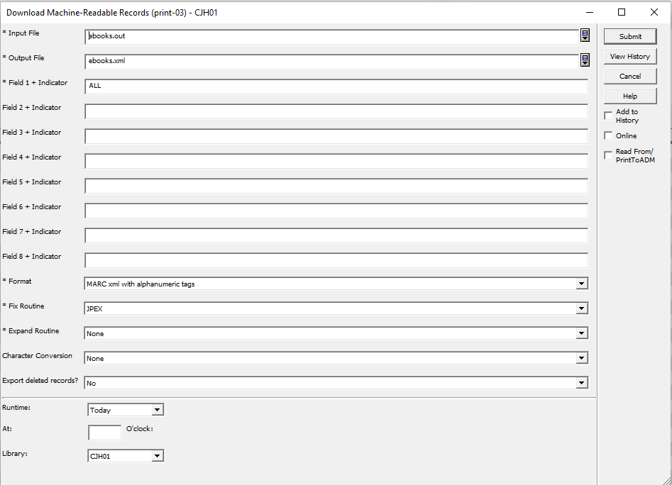

Again, we’re looking at the search we did in the tutorial. We want the complete record, so we need to type “ALL” in the Field 1 + indicator box. Our input file is the file we previously created with ret-01. Our output file, which will actually contain the records, we give the extension of the file format we want to download, in this case, .xml – we would use .mrc if we were downloading binary MARC records, for example. Ex Libris uses some proprietary alphanumeric tags, so make sure to select the option for your file format “with alphanumeric tags,” since we want the complete records. We select “JPEX” from the “Fix routine” dropdown for the same reason; otherwise we will not get the system numbers in the downloaded records.

Once the form is filled out, click submit and again follow its progress using the “Batch Log” tab. Once it finishes running you can use the “Download/Upload files” tab in the Administration tab to navigate to the CJH01/print directory where you can transfer the output file to your local machine.

