**How to Batch Delete Records**

Sept. 26, 2016 | J. Taylor

To completely delete a large number of records, along with their attached Item, HOL, and ADM records, rather than opening & deleting each record one by one, as described in “How to Delete a Record from Aleph.” Once deleted, records are not recoverable.

1. Retrieve records with (ret-01). 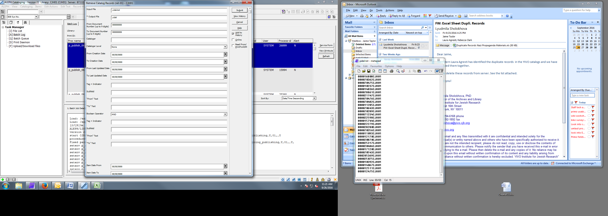
2. Use that output as input for Delete Bibliographic Records Including Related ADM.HOL Records (manage-33). Update database: yes.

