**Create an Input File for Aleph**

1. Certain services in Aleph require an input file in order to run. The easiest way to do this is create a .txt file from previously run report.
2. Open your Excel Report. Copy the System IDs for all the records that you want to work with.

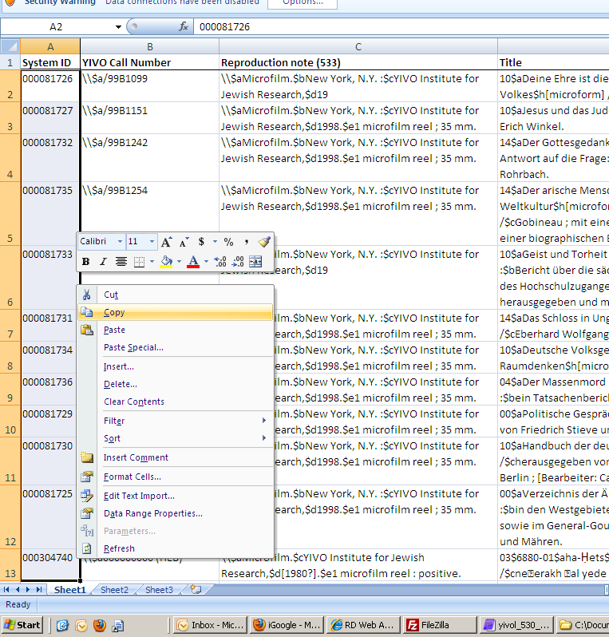

1. Tab over to a blank worksheet and paste the System IDs there. Add CJH01 to the column to the right. [Highlight the whole column; type “CJH01,” then press Ctrl+Enter to auto-fill the same thing into the whole column. –JT 6/1/15]

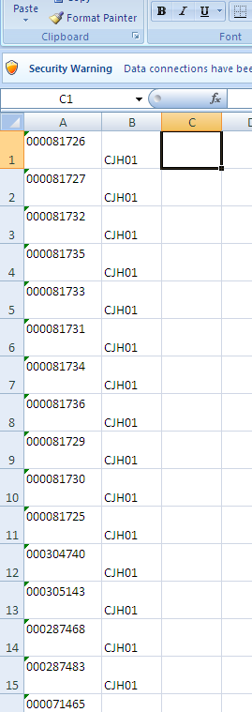

1. In the third column write out the function =A1&B1. Use Auto-fill to fill for every row.

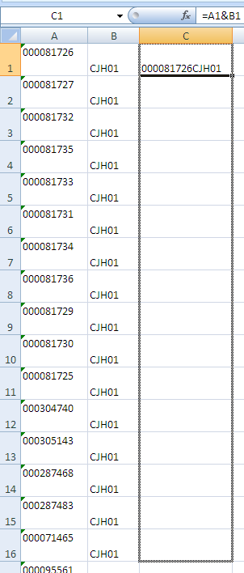

1. Copy Column C and paste into MetaPad.

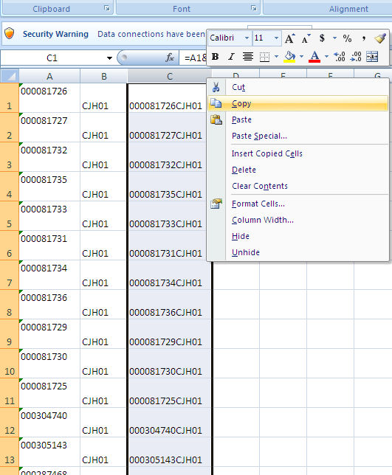

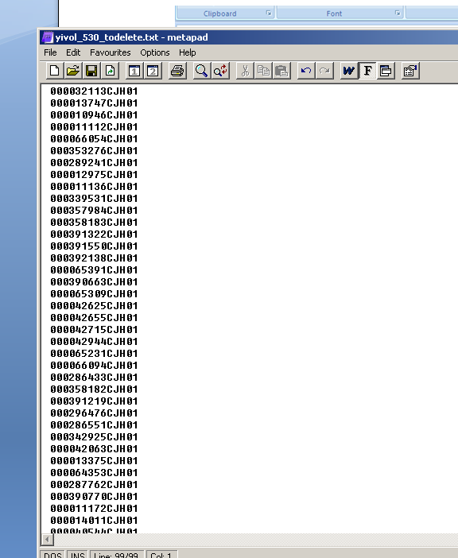

1. Change the File Format of the .txt file to UNIX Text (LF)

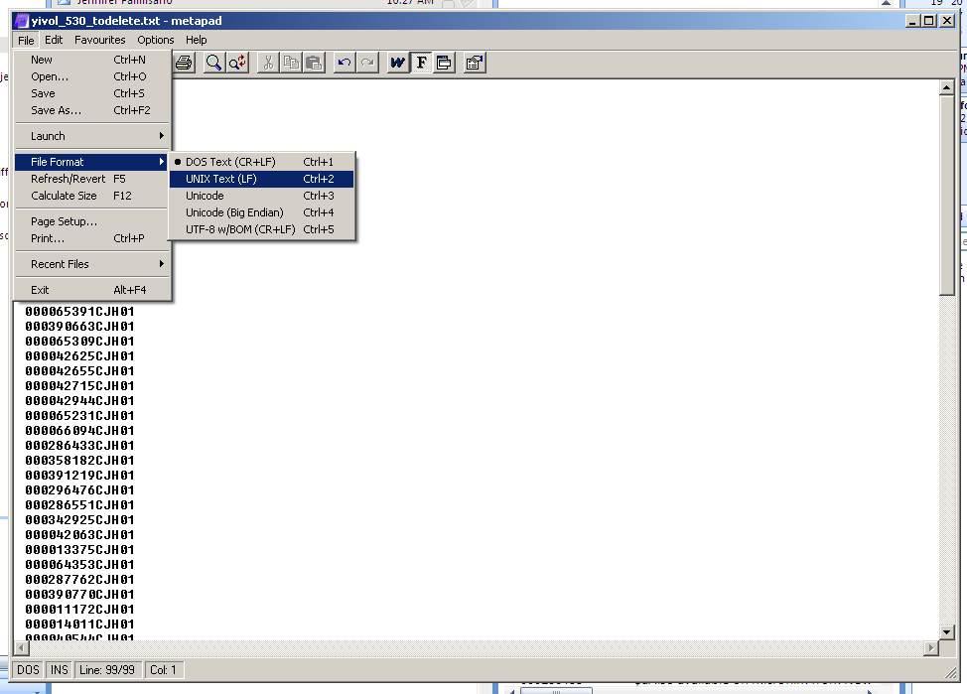

1. Save.
2. FTP this file to both /alephe & /cjh01.