Importing images:

1. 🡪Run:cmd

2. 🡪type: x: it will take you to the x:\ drive

3. 🡪dir -- see what is in the directory or cd to the directory you want to access… the same cd ..

4. 🡪dir > namefile.txt – to send the listing to a text file..

5. 🡪go excel 🡪Data 🡪Get External data 🡪 From text file 🡪import file 🡪For File name type drive letter X: then get the .txt file

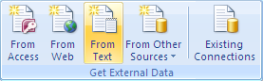

6. select Delimited

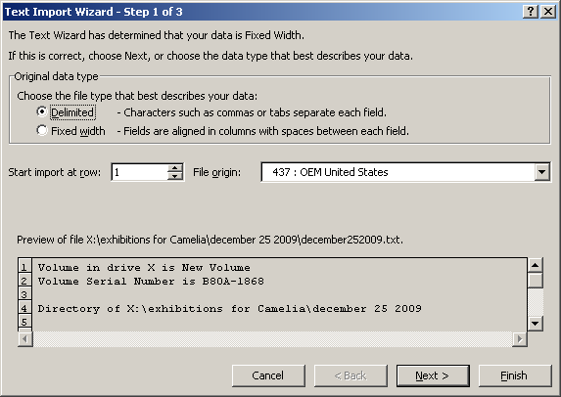

7. click Next 🡪 check the space box and make sure the name of images is whole and nothing is missing

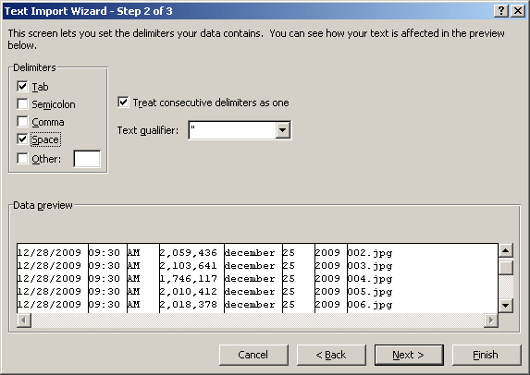

8. click Next or Finish

9. Click Ok

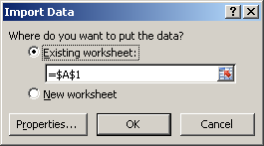

10. select all the rows with non important data right click on the numbered rows and click delete the same for the end of the file

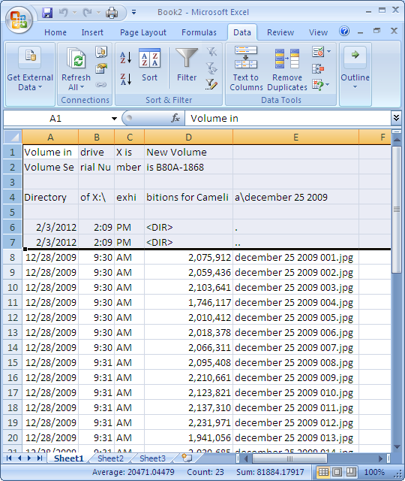

11. Select the top of the columns that don’t have the pertinent information as in the picture name

Then right click and select delete

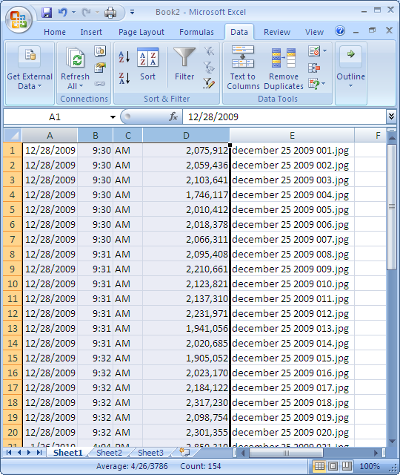

13. save the file and exit.

14. now to add the path for each picture:

* All data from column A (beginning at row 1).
* In column B, row 1, enter =”X:\exhibitions for Camelia\fundraising dinner 2006\” & A1

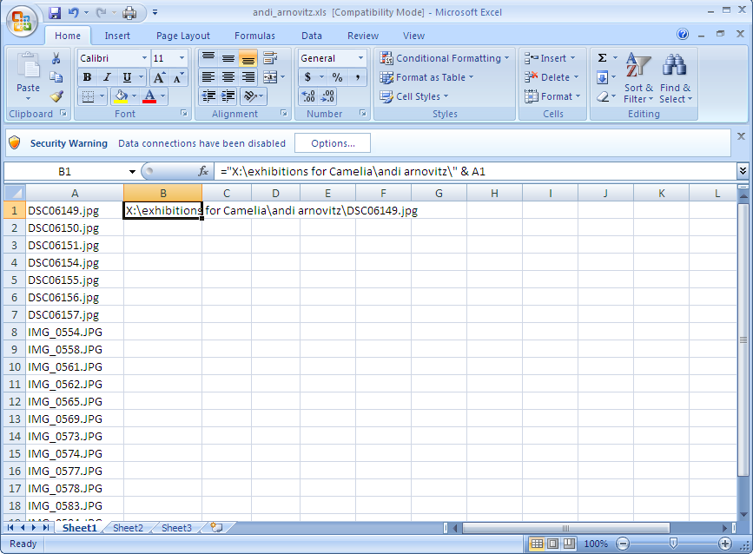

* Now select cell B1 right click to copy then go one cell down hand drag from the bottom right of cell down through all your rows (this copies the formula and uses the corresponding column A value.
* Save as a .csv file and exit.

16. Open the .csv file and delete the column A

17. first row right click 🡪 insert

18. first col right click 🡪 insert then A1 type:irn 🡪 A2 type irn number(ex. 319)

19. second column B1 type: MulMultiMediaRef_tab(+).irn

20. save as .csv and exit

21. open another excel spread sheet type A1: irn , A2:the number from before and B1: SecDepartment_tab, B2:YUM🡪save: *_yum.csv 🡪exit

22. you are ready to use the import tool in KeEmu:log into the KeEmu client as emu username/passwd

23. Open the Event module 🡪Tools🡪Import🡪select the *.csv file 🡪click import..click next, next, next

24. Open the Multimedia module 🡪Tools🡪Import🡪select the *.yum.csv