**Retrieving Records from Aleph**

1. Open the Cataloging Module. Go to Services> Retrieve Catalog Records > Retrieve Catalog Records (ret-01).

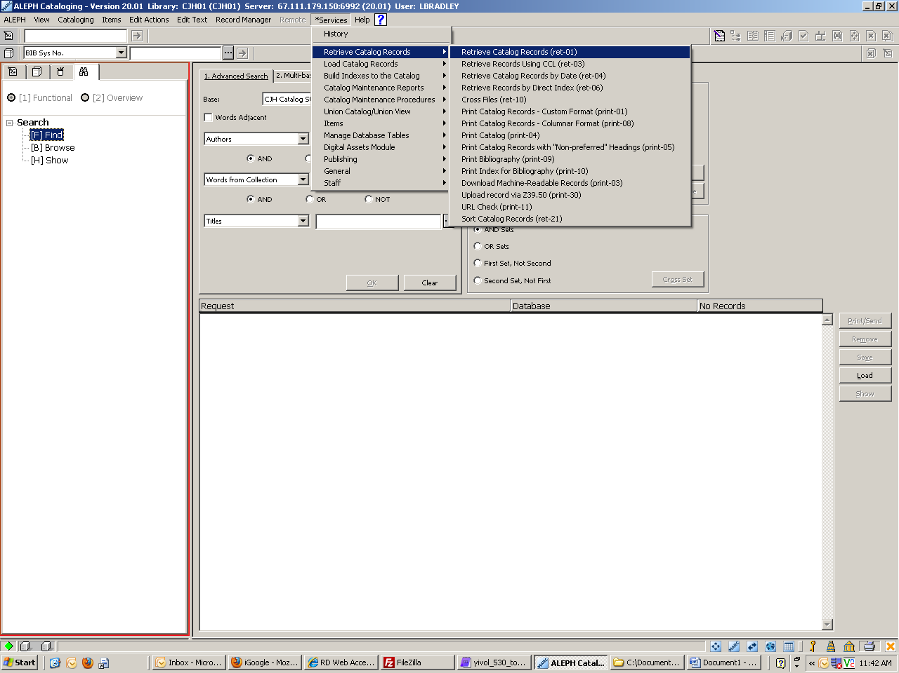

1. If you have an input file, enter it. Name your output file and make it something unique enough that you will remember it. Copy and paste exactly as written and save somewhere. Retrieval jobs will not show up in the task manager, so you will need to have the exact file name to pull up your results. Enter your search criteria. In this example, we are looking for all of YIVO’s records (OWN = YIVO) that have an 856 field. If we have additional criteria that we want to refine our search (such as now we want all of YIVO’s records with and 856 AND a 533 reproduction note), repeat this step, but use the output file name from the first run as the input file for the second run. If you are running a second retrieval, don’t forget to note the name of the second output file somewhere!

First retrieval: 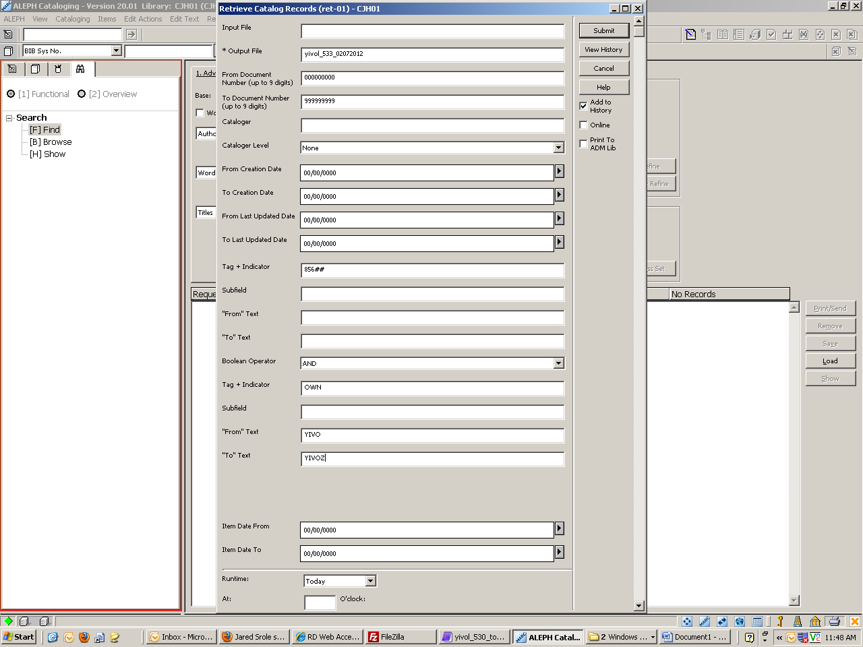

Second retrieval: 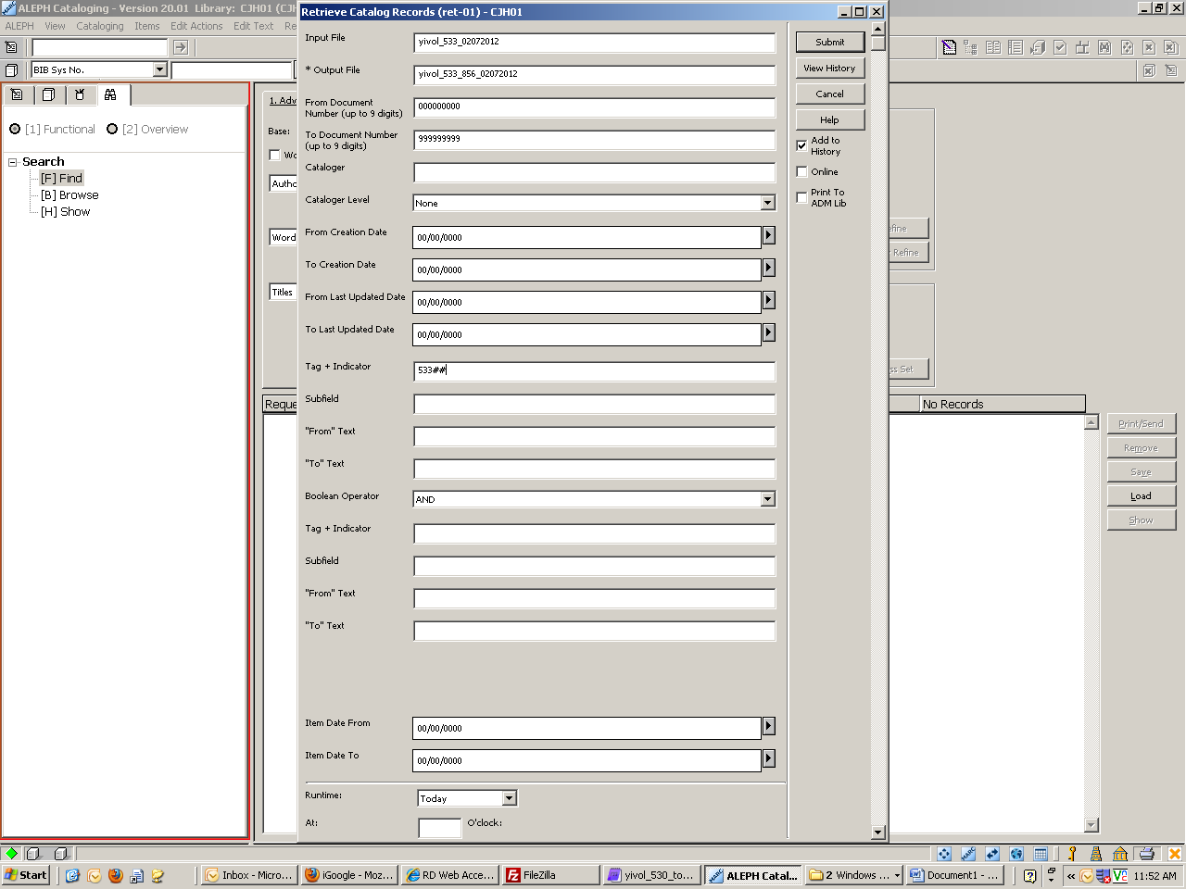

1. The output file can now be used as the input file to run other jobs, such as exporting records or making global changes.